Alive Music Video Proposal
Myself and Tom Clover will be making a music video for the song Alive by Chase & Status. The idea of the video is based around feeling alive which you can associate with Adrenaline or Freedom. We are going to use a range of extreme sports from Skateboarding to Kayaking to show what feeling Alive is to some people. Using sports gives us a lot to do for editing because of how fast paced the different sports are which compares well to the song.
The Audience
The target audience for this video is a number of different kinds of people, the music genre itself is light drum and bass so it will attract the enthusiasts of this genre. The underlying theme of the video is adrenaline and adrenaline producing sports, so extreme sports enthusiast will also be a target audience. Because we have a wide range of extreme sports within the video it will appeal to more than one scene of the sub genres of extreme sports. Drum and Bass appeals to young adults as it is mostly played at raves and nightclubs where there is mainly a large majority of young people. On the mosaic classification chart the target audience the music video will appeal to is urban cool which comes under liberal opinions. These people are young, well-educated and fashionable/stylish.
Within the video we want to have bright, vibrant colours which are aesthetically, these colours will show how the actors feel towards the sports, this is because you associate bright colours with happiness.
Requirements of the Band
After looking at Chase and Status’s video they have quite dark theme with a narrative, we want to create a contrast with the videos that they make. Are video has an underlying theme of adrenaline so it will fit into the tone of the song. It will bring more viewers to support chase and status because the video will include a vary of sports which attract a huge scene of potential audience for chase and status. The music video portrays the song because of the theme of the song is relatable to all that is going on within the video. Everything within the video releases adrenaline so it portrays the song with the video.
Content
The music video starts with a time lapse of the Sunrise on Westbury Whitehorse. The sunrises east, over Westbury allowing us to have the town in the bottom of the background. At 15 seconds it will cut to shots of Tom standing with his arms out looking over Westbury, this emphasizes the meaning of our music video, 'Feeling Alive'. There will then be a close up on Toms face singing part of the lyrics while he looks out into the distance.
It will then cut to a shot of two Downhill Skateboarders (Longboarders) Standing at the brow of a hill they are about to skate. Just as the bass is about to drop in the song the two Longboarders will fist bump and skate down the hill. We will use a range of shots, from Close ups to show their emotions and low long shots to show how fast they are going. From this it will go to a montage of a Motocrosser on a race track. We have got access to Go Pro's allowing us to get some POV shots.
When the beat slows down in the song it will cut away to a person in a kayak cruising up river. We will have slow motion shots of the water splashing off the paddle to make it more interesting. When the beat starts to pick up there will be a shot of Tom jumping off the diving board at the location we are filming at.
As soon as Tom hits the water it will jump cut to the downhill mountain biker going off a jump, when he lands it will then jump cut again to him going down the straight of the track. The next scene is at Melksham Skate Park where there will be multiple shots of Skateboarders and Rollerblades.
The Music video will finish with another time lapse at Westbury Whitehorse as the sunsets. The camera will be in near enough the same location.
Style
The style of the video will be very fast and quick cutting, we will try to keep every shot moving and fluent to keep the video more engaging. The underlying theme of adrenaline so we want to pass that feeling onto the viewers with engaging exciting shots. We want to include some arty shots as well so there will be shots revealing from behind an object that is aesthetically pleasing. For example one of the shots will be the roller blader walking towards the skate park but will be revealed from behind a tree with a close up of the bark.
We want to have a film grainy feel to the video with lots of sun glare coming into the shots, I like how the light comes into the shots and can help us achieve the style we want without actually putting a filter over in post-production.
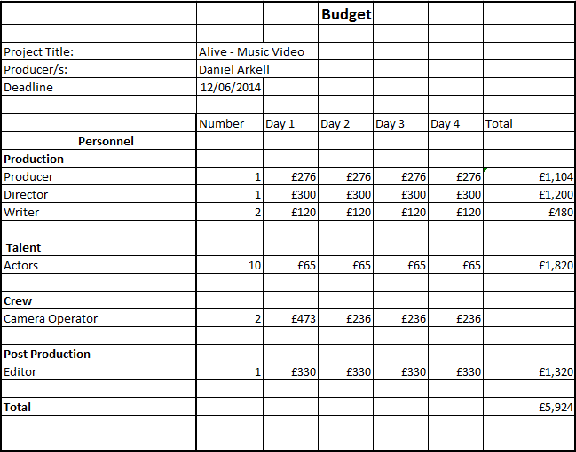
Budget
Legal Ethic Requirements
Are music video will be ethically right because the video has a very young audience we do not want to attract anyone for the wrong reason so we will not have any sexually arousing scene. We will not be stereotyping any minority that is within the video for example if there was black person we would not portray them to be a bad character within the narrative.

